Quantum Acoustics –
Surface Acoustic Waves meets Solid State Qubits (May 17-20, 2016)

This is a proposal for a SPICE workshop with the above title.

Organizers:
- Christoper Bäuerle, Directeur de Recherches, CNRS, Institut Néel, Grenoble France
- Göran Johansson, Professor, Chalmers University of Technology, Gothenburg Sweden (primary organizer)
- Paulo Santos, Senior Scientist, Paul Drude Institut für Festkörperelektronik, Berlin, Germany
- Floris Zwanenburg, Assistant Professor, Universiteit Twente, Enschede, The Netherlands

Paulo Santos represents the SAW community. Christopher Bäuerle together with Floris Zwanenburg span the solid-state spin qubit community. Göran Johansson represents the superconducting qubit community.

General motivation:
This workshop aims at boosting the new field of quantum acoustics ‐ a phonon analogue of quantum optics on chip – where single phonons in the form of high‐frequency surface acoustic waves (SAWs) propagate in acoustic waveguides coupling remote qubits. The phonons can also be captured in high‐Q cavities for storage and to increase coupling with the qubits. The envisioned impact of the workshop is to motivate scientist to collaborate to demonstrate coherent coupling between multiple solid-state qubits of different nature, on the same substrate.

Aspects of Interdisciplinarity:
This brings together three scientific fields which have not interacted substantially before, i.e.:
1) SAW, 2) Solid State Spin Qubits and 3) Superconducting Qubits

There are a few results on using SAW to manipulate spin qubits [J. A. H. Stotz, et al., Nature Materials B, 585 (2005), B. Bertrand et al., arXiv:1508.04307 (2015) ], but they all use SAW in the large amplitude classical regime. It was recently demonstrated that a superconducting qubit could be coupled preferentially to a SAW waveguide, with the possibility to absorb and emit SAW coherently at the single phonon level [M.V. Gustafsson, et al., Science 346, 207 (2014)]. There is also a theoretical proposal discussing the feasibility to use these quantum SAW as interconnect between different solid-state qubits, including electronic and nuclear spin qubits, superconducting qubits and NV centers [M. J. A. Schuetz et al., Phys. Rev. X 5, 031031 (2015).].

Participants, Key speakers:
We aim at least 25 participants, but not more than 40.
Including both seniors, post-docs and PhD-students from the relevant groups around the organisers and the key invited speakers, as well as a number of other interested scientists.

The Key speakers are:

Tristan Meunier, Institut Néel, Grenoble,
on how to use SAW to transport electronic spin qubits
(already expressed interest to participate)

Per Delsing, Chalmers University of Technology, Sweden,
on how to couple superconducting qubits to SAW
(already expressed interest to participate)

T. Fujisawa, Tokyo Institute of Technology:
Interaction of spin qubits with acoustic vibrations.

Chris Ford, Cavendish Laboratory, Cambridge
to be defined

Hubert Krenner, Univ. of Augsburg,
“Coherent coupling of quantum states using SAWs”

Haruki Sanada, NTT-Basic Research Lab., Atsugi, Japan, “Transport and manipulation of spins using surface acoustic waves”
Paulo Santos, Paul Drude Institute
on SAW
(organiser)

Peter Leek, Oxford,
on how to make low temperature, high frequency, high Q, SAW cavities

Mikhail Lukin, Harvard,
on solid-state qubits and SAW, large scale architectures

Lieven Vandersypen, Delft,
on solid-state qubits and SAW, large scale architectures

Wilfred van der Wiel, Twente,
SAWs and spin qubits in silicon
(already expressed interest to participate)
Andreas Wallraff, ETH Zurich,
on superconducting circuits and quantum dot qubits

H. Yamaguchi, NTT-Basic Research Labs
nanomechanical oscillators

Preferred dates of the workshop:
4-5 days, at Schloß Waldthausen, late spring or early autumn 2016

Poster Motif:
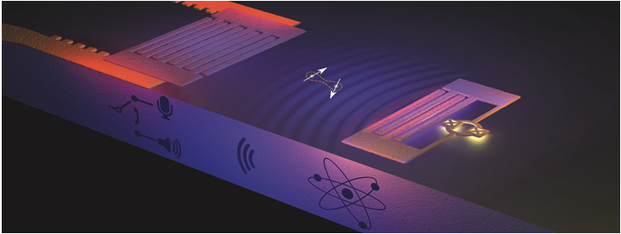
Illustration: Moa Carlsson and Lisa Kinnerud, Krantz NanoArt

Possible co-sponsors:
The organizers are awaiting the decision on an application for a European project on this topic. If the answer is positive, there will be possibilities to support this workshop from the project.

